* **Information on the license that will be required to use Bamboo CI/CD?**

Atlassian offers several types of licenses for Bamboo:

1. **Starter License** – The pricing $10 - $100 per year, depending on the number of agents. This license is ideal for small teams of up to 10 users who need to automate their builds and deployments. It allows us to use Bamboo for an unlimited number of plans and builds.
2. **Academic License** - Free for eligible institutions. This license is available to accredited academic institutions, including schools, universities, and non-profit organizations. The license allows for unlimited users and agents, but it cannot be used for commercial purposes.
3. **Commercial License** - Starts at $10 per month for up to 10 users. The price increases based on the number of users and agents required. This license is ideal for businesses of all sizes that need to automate their build and deployment processes.
4. **Data Center License** - Data Center License: Starts at $12,000 per year for up to 500 users. The price increases based on the number of users required. This license is designed for large enterprises that need to scale their continuous integration and delivery processes across multiple teams and locations.

**Note:** **The type of license we will need depends on the size of our organization, the number of users who will be using the software, and the level of support you require.**

* **In the context of Bamboo, a user refers to an individual or entity that interacts with the Bamboo software or system. Users can be broadly categorized into two groups:**

**Bamboo Administrators:** These are users who have administrative access to the Bamboo system and are responsible for configuring, managing, and maintaining the Bamboo environment. They have access to all Bamboo features and can create, manage, and delete plans, jobs, and build agents. Bamboo administrators are typically technical users who have knowledge of software development, build processes, and deployment workflows.

**Bamboo Users:** These are users who interact with the Bamboo system to perform specific tasks related to software development, testing, and deployment. Bamboo users can include software developers, testers, project managers, and other stakeholders involved in the software development lifecycle. They typically have access to a subset of Bamboo features, such as creating and triggering builds, viewing build logs and reports, and monitoring build status.

The number of Bamboo users can vary depending on the size of the organization, the complexity of the software development process, and the number of projects being managed using Bamboo.

* **Application server required for the implementation of Bamboo CI/CD**

1. Apache Tomcat

**Note:** Bamboo CI/CD is a web-based application that runs on a Java application server.

* **Databases required for the implementation of Bamboo CI/CD**

1. MySQL

**Note:** It is worth noting that if we plan to use Bamboo in a clustered configuration or with Atlassian's Data Center edition, we will need to use a dedicated database server or cluster for Bamboo. This is necessary to ensure high availability and performance.

* **Server requirements for remote agents for Bamboo CICD**

General recommendations for server requirements for remote agents in Bamboo:

1. **Operating System:** Atlassian recommends using a recent version of a stable and supported Linux distribution, such as Ubuntu, CentOS, or Red Hat Enterprise Linux.
2. **CPU:** Bamboo agents benefit from multi-core CPUs, so it is recommended to use a server with at least two cores. Depending on the size of our builds, we may need to consider using a server with more cores
3. **Memory:** Atlassian recommends using a server with at least 2 GB of memory. For larger builds or for running multiple concurrent builds, we may need to consider using a server with more memory.

Atlassian recommends the following system requirements for Bamboo:

For up to 20 agents: 4GB RAM, 2 CPU cores, and 10GB disk space

For up to 50 agents: 8GB RAM, 4 CPU cores, and 10GB disk space

For up to 100 agents: 16GB RAM, 8 CPU cores, and 15GB disk space

1. **Disk Space:** Atlassian recommends using a server with at least 10 GB of free disk space. But the amount of disk space required will depend on the size of our build artifacts and the number of builds we plan to run.

* **Here are some general recommendations of specifications for Remote sever**

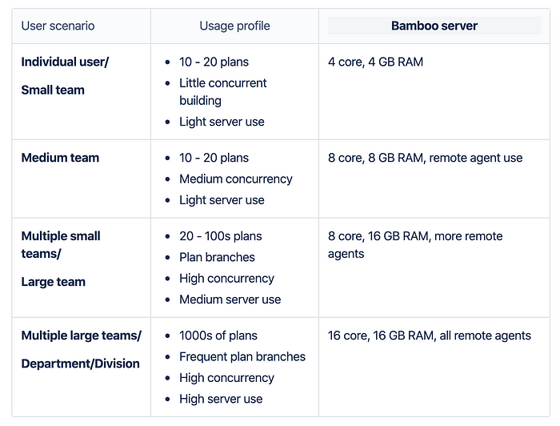

* **Necessary details on the application architecture required to implement the automated CI/CD pipelines in bamboo.**

In this architecture, we have three components:

1. **Apache Tomcat**: It is a web server and servlet container used to run Java web applications. In this setup, it is installed on one server and used to host the Bamboo application.
2. **MySQL:** It is a relational database management system used to store data. In this setup, it is installed on a separate server and used to store Bamboo's configuration and data.
3. **Bamboo:** It is a continuous integration and continuous deployment (CI/CD) server used to automate the build, test, and deployment of applications. In this setup, it is installed on the Apache tomcat server.
4. Complete application architecture diagram

**Complete application architecture and how the components communicate with each other, including the protocols and ports used:**

1. **Presentation Layer:** Apache Tomcat is used as the presentation layer, which listens on port 8080 by default. When a user sends a request to the Apache Tomcat server via a web browser, Apache Tomcat receives the request using the HTTP protocol over port 8080. Apache Tomcat then forwards the request to the Bamboo application running on the same server.
2. **Application Layer:** Bamboo is installed on the Apache Tomcat server and serves as the application layer, which listens on port 8085 by default. When a request is received from Apache Tomcat, Bamboo processes the request and sends a response back to Apache Tomcat over port 8085 using the HTTP protocol.
3. **Data Layer:** MySQL is used as the data layer, which listens on port 3306 by default. When the Bamboo application needs to store or retrieve data, it communicates with the MySQL database server installed on a separate server using the MySQL protocol over port 3306.
4. **Source Control Management (SCM):** Bitbucket is used as the SCM tool, which communicates with the Bamboo application over the network using the Git protocol over port 7999 by default. When a user commits code changes to the Bitbucket repository, Bamboo detects the changes and initiates a build process.
5. **Project Management Tool:** Jira is used as the project management tool, which communicates with the Bamboo application over the network using the REST API over port 8080 by default. When a user creates a Jira issue related to a specific build or deployment, Bamboo can automatically associate the issue with the relevant build or deployment.

Communication between the Apache Tomcat server, Bamboo application, MySQL database server, Bitbucket SCM, and Jira project management tool happens over the network using the protocols and ports described above. To ensure secure communication between the components, it's important to configure the network settings correctly, such as configuring firewalls to allow traffic over the necessary ports, encrypting communication using SSL/TLS, and securing the MySQL database server to only accept connections from trusted sources.

Overall, this architecture provides a scalable, secure, and flexible solution for deploying and automating CI/CD workflows using Bamboo, with Bitbucket as the SCM tool and Jira as the project management tool.

* **Branching model of Bitbucket:**

**Live**

**Staging**

**QA**

**Dev**

* **Also here is workflow of bamboo CICD:**

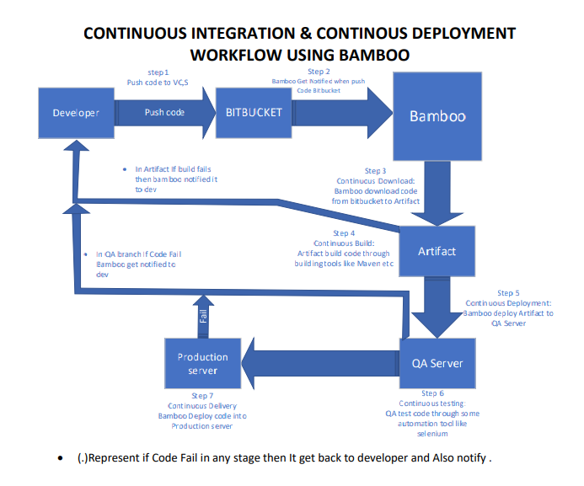

**\*All highlighted content is recommended other content is for comparisons**